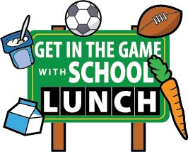
National School Lunch Week (NSLW) is October 13th – 17th, 2014. The theme is “Get in the Game with School Lunch”! We want you as School Nutrition Employees in Montana to encourage kids to find the balance between Healthy Eating and Physical Activity. Did you know that there are FREE Resources available for you as a member of the School Nutrition Association! If you are a member, LOG IN and see what you want to use for your school on NSLW! SNA did the work for you to be able to carry it forward to your districts.
How often do we hear or say ourselves that we just don’t have time? Well, the benefit of being a SNA member is here for you! Use the resources they are giving you and give your program, yourself and your staff a boost. Shout loud and proud for your programs and tell everyone what you are doing at your district! Please send some other ideas you may have and we will get it up on the website to share with others around the state so they may benefit from your work as well. Send any information and photos that you have as soon as possible to: jennifer_spellman@gfps.k12.mt.us .
YOU CAN DO IT! Get the Media, Parents, Faculty and Staff to pay attention to what you do for kids every day! Let them know how important School Nutrition is to your community, your schools and your kids!
